General Photo Requirements
- Templates: As indicated in the sample photos for digital and paper photos.
- Dimensions: The digital photo should be between 354 pixels (width) x 472 pixels (height) and 420 pixels (width) x 560 pixels (height). The paper photo should be 33 mm (width) x 48 mm (height).
- Colour Space: RGB 24-bit true colour.
- Image Compression: JPEG and the image file size: 40 KB-120 KB.
- Facial Requirements: The applicant is required to present the frontal view to the camera with the entire head and face clearly visible. The facial expression must be neutral with eyes open, mouth closed and ears visible. There should be no visible distortion of the facial features. There should not be any object such as hand or toy or another person visible in the photo. Eyeglasses are allowed in the photo only if the lenses are not tinted and there is no glare, shadows, or frames obscuring the eyes. The head position: ≤ 20° for left or right tilt (Yaw and Roll) and ≤ 25° for up or down tilt (Pitch).
- Head Coverings: Hats or other head coverings are only allowed if worn for religious reasons and if they do not obscure any facial features.
- Photo Quality: The photo should have no damage or impurities, no background light or shadow over face. There should not be over-or under exposure. The face should be centered in the photo with all the features clearly visible and natural skin tone. The inter-eye distance should >60 pixels.
- Head Size and Orientation for the Digital Photo: With the digital photo of 354 pixels (width) x 472 pixels (height) as an example, the head should be horizontally centered in the image with the face width at 205 pixels ±14 pixels. The space from the upper edge of the image to the crown of the head should be 10-70 pixels. The vertical distance from the bottom edge of the image to the horizontal line through the centre of the eyes should >256 pixels. In special cases, when the hair is too high, the voluminous hair can be trimmed off to ensure the size of the face.
- Head Size and Orientation for the Paper Photo: The head width should be between 15 mm and 22 mm and the head height, measured from the base of the chin to the crown of the head, should be between 28 mm and 33 mm. The space between the crown and the upper edge of the photo should be between 3 mm and 5 mm. The space between the chin and the bottom edge of the photo should ≥7 mm
- Background and Borders: The background of the photo should be white or close to white with no borders around the edge of the image.
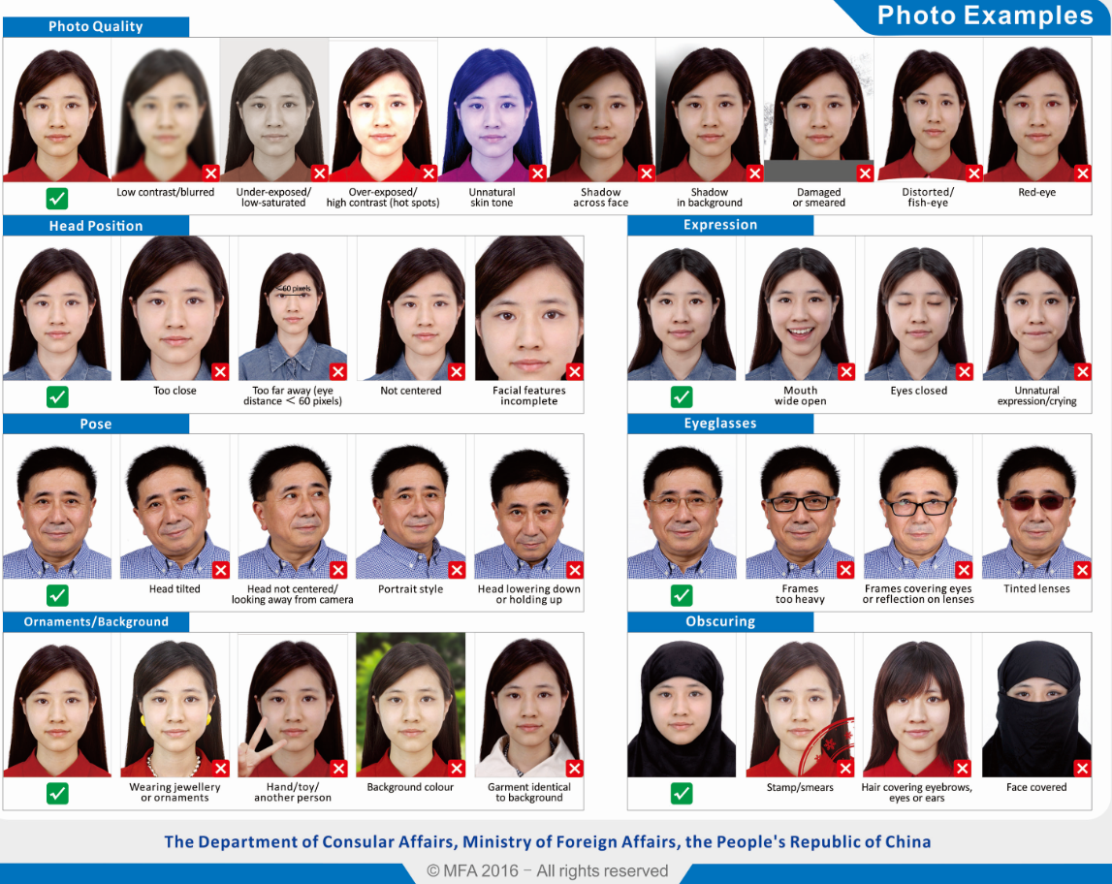
- The photo should be recent, taken within 6 months.

